**HOME CHALLENG (LED ON OFF CIRCUIT USING SWITCH)**

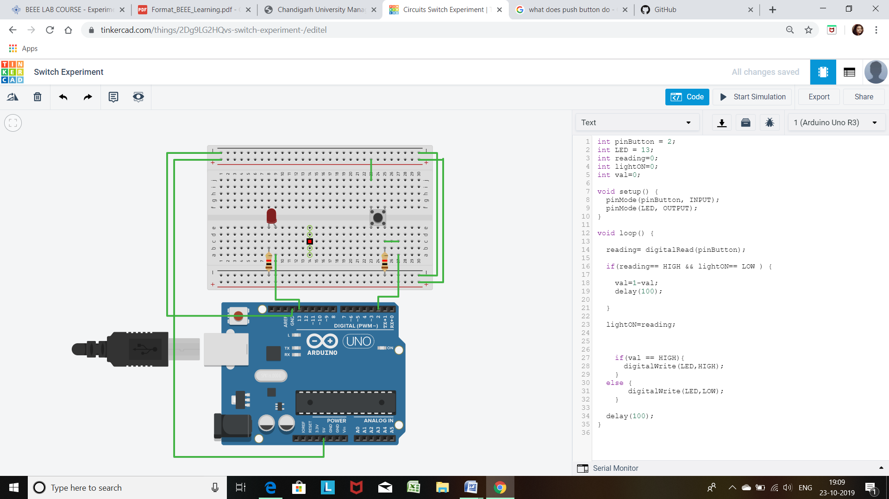

**CODE**

int pinButton = 2;

int LED = 13;

int reading=0;

int lightON=0;

int val=0;

void setup() {

pinMode(pinButton, INPUT);

pinMode(LED, OUTPUT);

}

void loop() {

reading= digitalRead(pinButton);

if(reading== HIGH && lightON== LOW ) {

val=1-val;

delay(100);

}

lightON=reading;

if(val == HIGH){

digitalWrite(LED,HIGH);

}

else {

digitalWrite(LED,LOW);

}

delay(100);

}